**CmpE 124 Lab 3: Mixed-Logic Circuit Design**

Hoang Le, 012679771, CmpE 124 Spring 2019, Lab Section 03

***Abstract* — The purpose of this lab is converting a voltage table into an equation in order to design a circuit. And using the binary counter to adjust the output of the circuit with assigned chips.**

1. INTRODUCTION

Mixed logic circuit design is a challenge for student to practice on how to build a real circuit based on data. Using the given voltage table to design circuit. Student will test the design with Logic Work and actual circuit.

# Design methodology

1. Changing the voltage table into Truth table.
2. Converting the truth table into the logic table
3. Write the logic equation design for the circuit from the logic table
4. Build the circuit on Logic Work with assigned chip and then student will test and compare the circuit on Logic Work.

## Parts List

Part 1:

* 1 SN74LS04N
* 1 SN74 LS163AN
* 1 SN74 LS00N
* 1 SN74 LS10N
* 1 Crystal FS10.00P
* 1 100pF Capacitor

Part 2:

* 2 SN74 LS20
* 1 SN74LS04N
* 1 SN74LS163AN
* 1 Crystal FS10.00P
* 8 1KΩ Resistors
* 1 100pF Capacitor

## Truth table

**Table I**: Truth table of the Decoder.

|  |  |  |  |  |  |  |
| --- | --- | --- | --- | --- | --- | --- |
| Inputs | | | Outputs | | | |
|  |  |  |  |  |  |  |
| 1 | 0 | 0 | 0 | 0 | 0 | 1 |
| 1 | 0 | 1 | 0 | 0 | 1 | 0 |
| 1 | 1 | 0 | 0 | 1 | 0 | 0 |
| 1 | 1 | 1 | 1 | 0 | 0 | 0 |
| 0 | X | X | 0 | 0 | 0 | 0 |

**Table II**: Truth table of the multiplexers

|  |  |  |  |  |  |  |  |
| --- | --- | --- | --- | --- | --- | --- | --- |
| Inputs | | | | | | | Outputs |
| g | b | a | d3 | d2 | d1 | d0 | z |
| 1 | 0 | 0 | x | x | x | 0 | 0 |
| 1 | 0 | 0 | x | x | x | 1 | 1 |
| 1 | 0 | 1 | x | x | 0 | x | 0 |
| 1 | 0 | 1 | x | x | 1 | x | 1 |
| 1 | 1 | 0 | x | 0 | x | x | 0 |
| 1 | 1 | 0 | x | 1 | x | x | 1 |
| 1 | 1 | 1 | 0 | x | x | x | 0 |
| 1 | 1 | 1 | 1 | x | x | x | 1 |
| 0 | x | x | x | x | x | x | 0 |

## Kmap

Not Applicable

## Original and Derived Equations

**Part1 equation:**

**Part2 equation:**

## Schematics

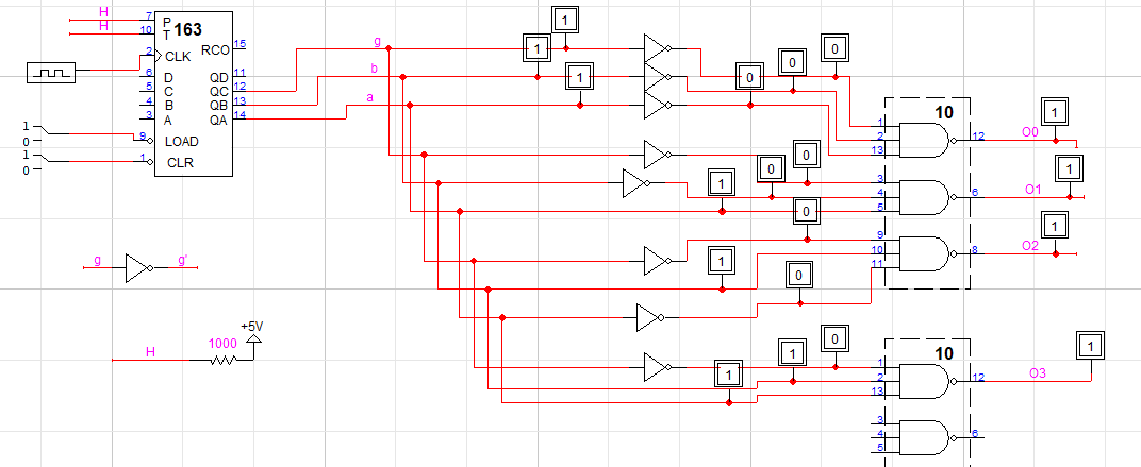

**Figure 1**: Designed circuit for Decoder in Logic

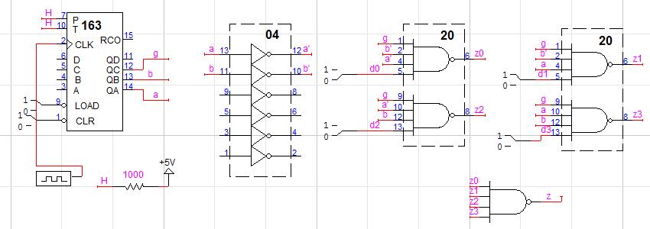

**Figure 2**: Designed circuit for Mux in Logic Work

# testing procedures

Decoder:

Step 1. Build the actual circuit for part 1

2. Connect the outputs of 163

to the input g, b, a of the circuit

3. Testing and compare the output on

oscilloscope

Mux:

1. Build the actual circuit for part 2

2. Hook up the outputs of

163 to the input g, b, a of the circuit

3. Connect the dip switches to the

output of the circuit input.

3. Testing the switch = LHLH

= HHLL; = HLLH and obtain waveforms

# testing results

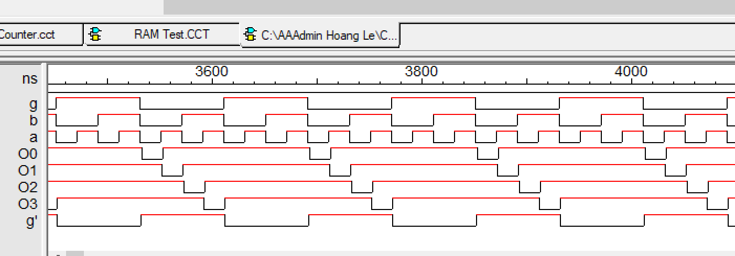

**Figure 3**: The wave form of g, o3, o2, o1, o0 from Logic Work.

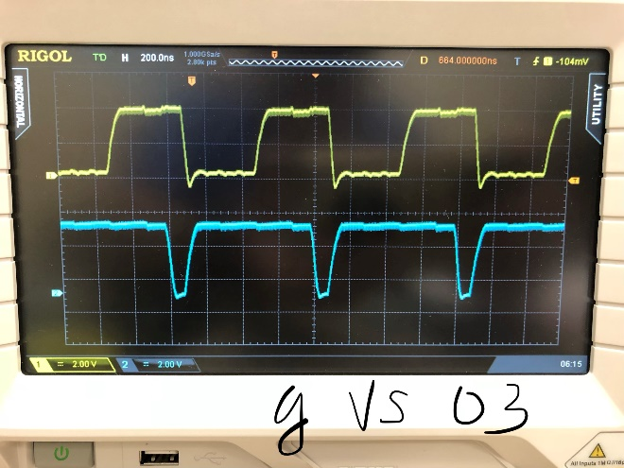

**Figure 4**: The wave form of g (yellow) and o3 (blue) from Oscilloscope.

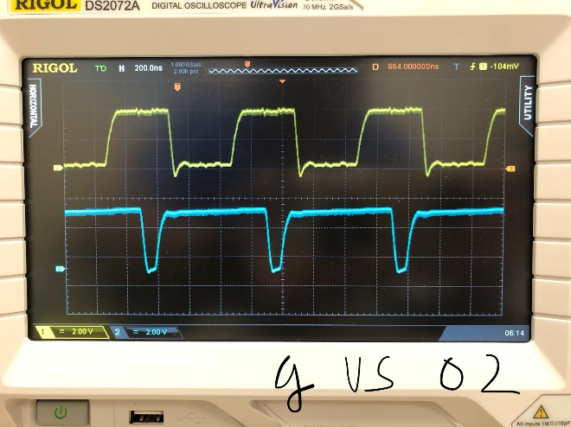

**Figure 5**: The wave form of g (yellow) and o2 (blue) from Oscilloscope.

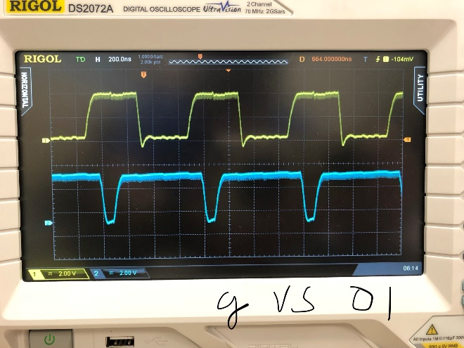

**Figure 6**: The wave form of (yellow) and o1 (blue) from Oscilloscope.

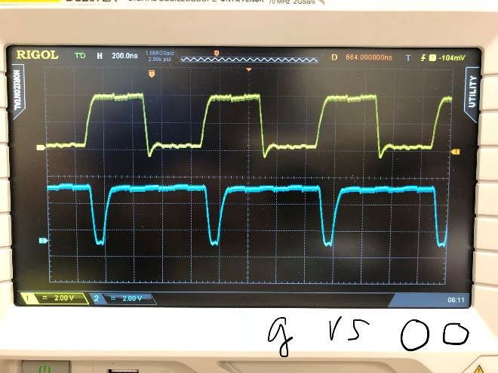

**Figure 7**: The wave form of g (yellow) and o0 (blue) from Oscilloscope.

Note: For the Decoder, the shape of the output waveforms from Logic Work and on the Oscilloscope screen are the same.



**Figure 8**: The wave form of g and HHLL from Logic Work.

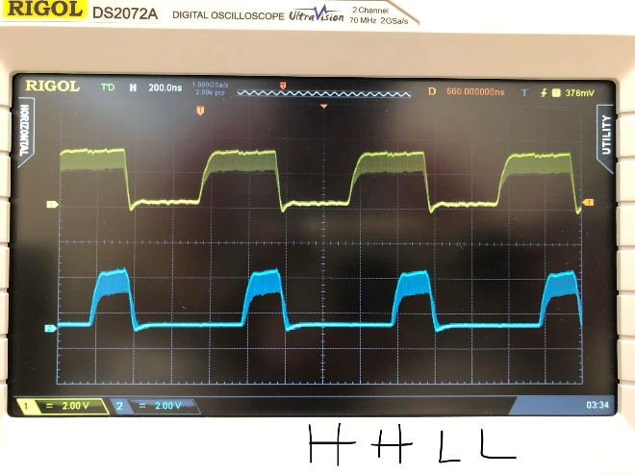

**Figure 9**: The wave form of g (yellow) and HHLL (blue) from Oscilloscope.



**Figure 10**: The wave form of g and HLLH from Logic Work.

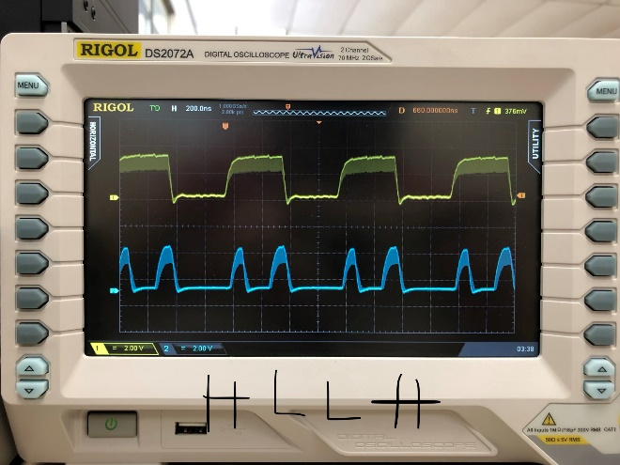

**Figure 11**: The wave form of g (yellow) and HLLH (blue) from Oscilloscope.



**Figure 12**: The wave form of g and from Logic Work.

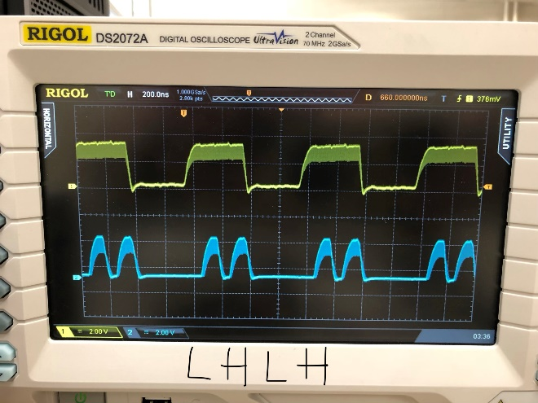

**Figure 13**: The wave form of g (yellow) and LHLH (blue) from Oscilloscope.

Note: For the Mux, the shapes of the waveform on Oscilloscope screen are matching with the ones from Logic Work.

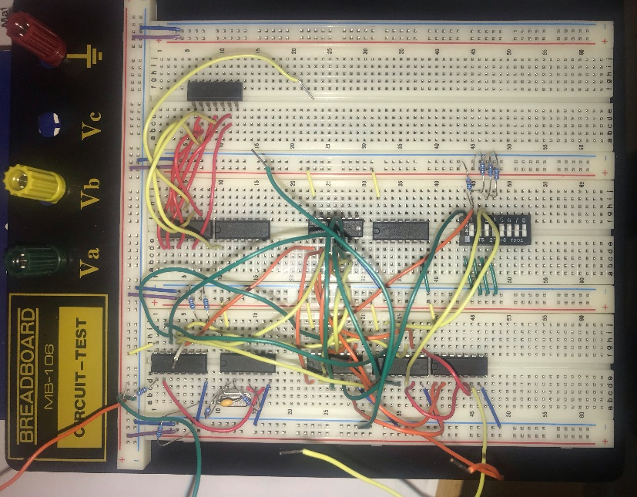

**Figure 14**: The circuit was assembled for the experiments in the lab.

# Conclusion

Throughout the lab, student gain more experience on how to design a circuit from logic work. And better understand of how Decoder and Multiplexer work. At the first attempt building the circuit, the decoder work properly, and it comes up with the same waveform of the Logic Work. However, the Mux circuit was bit confuse on how to connect it with the dip counter and adjust them. Student need to rebuild the circuit carefully and it came out with a successful result after many attempt.

1. appendices and References

Khalil A.Estell , Mikko Bayabo, Harmander Sihra, Haluk Ozemek. CMPE124 Digital Design I, Course Manual. Khalil A.Estell,